**Google’s Tensor chip is only the first step toward truly great Pixel phones!!**

***Google’s Pixel 6 is shaping up to be the company’s most ambitious smartphone in years, due to the new, custom-designed Tensor processor.***

**What does Tensor processor aim at??**

Tensor processor, which aims to catapult Google to the forefront of the smartphone market with the power of Google’s years of machine learning experience. And Google needs it: despite the popularity of Pixels in tech circles, its phones just aren’t popular sellers in the US, **[barely moving the needle](https://arstechnica.com/gadgets/2020/06/idc-google-outsells-oneplus-with-7-2-million-pixel-smartphones-in-2019/)** compared to **[juggernauts like Samsung and Apple](https://www.counterpointresearch.com/us-market-smartphone-share/)** or even **[smaller players like Oppo or Xiaomi](https://www.counterpointresearch.com/global-smartphone-share/).**

**What does Tensor processor promise to improve??**

Tensor is Google’s big bet, centered on the AI-boosting TPU that promises to improve **photos and videos, search, captioning, text-to-speech**, and more. It’s a tall order for any chip, much less one focused mainly on machine learning as its standout feature — but while the Tensor SoC might not launch Google to **[iPhone-like heights](https://www.theverge.com/21524288/apple-iphone-12-pro-review)** just yet, it could be a crucial first step toward turning its Android also-ran into a top contender.

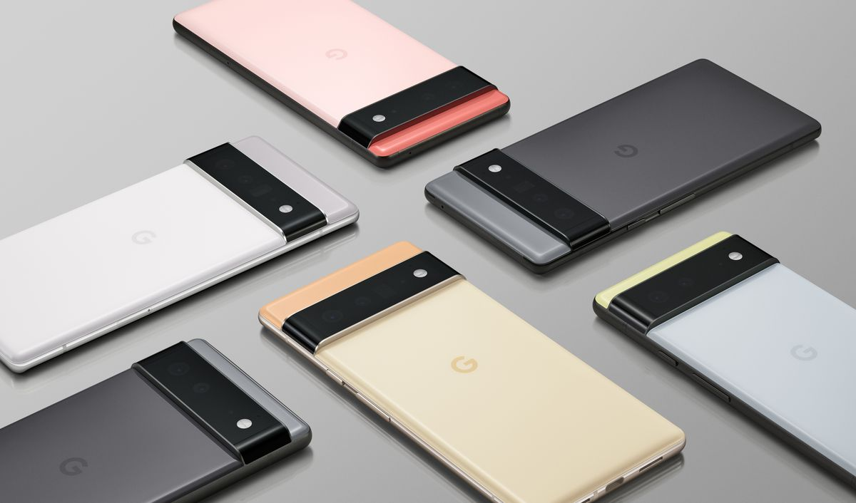

6 days ago

The rest of the SoC is a mystery right now, but it seems like Google will be using third-party designs for things like the CPU, GPU, and modem — meaning that the Pixel 6 will probably feel pretty similar to any other Android smartphone powered by a Qualcomm or Samsung processor for most tasks, instead of some sort of revolutionary upgrade on par with Apple’s A-series powered iPhones.

**What information it has??**

Google hasn’t given a lot of information about what Tensor’s actual architecture is going to look like for things like the CPU, GPU, modem, or other major components of the SoC beyond the TPU. But based on rumors and the fact that Google isn’t taking the chance to crow about any major customization or advances its made here, it’s likely the case that most of Tensor’s hardware stack will be outsourced designs. **Qualcomm and Samsung** already do something similar — the **Snapdragon 888** uses partially customized versions of **[Arm’s Cortex-X1, A78, and A55 designs](https://www.theverge.com/circuitbreaker/2020/5/26/21267893/arm-cortex-a78-mali-g78-cpu-gpu-designs-smartphones-2021-samsung-qualcomm-apple)**, while **Samsung’s Exynos 2100** uses Arm designs for both its CPU and GPU.

**[XDA notes](https://www.xda-developers.com/google-pixel-6-custom-system-on-chip/" \l "update1)** more specifically that the Tensor will likely be some combination of **Arm’s Cortex-A78, Cortex-A76, and Cortex-A55 CPU cores and Arm’s standard Mali GPU**. Which means that the difference between Tensor and, say, a **Snapdragon 888** or **Exynos 2100** might not be that major for things like overall CPU or GPU performance. That’s a good category to be in, especially if Google is trying to truly make a **flagship device**.